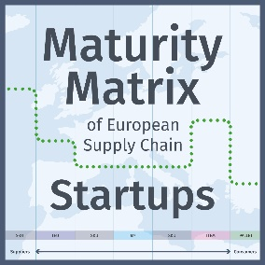**Input Form for the Maturity Matrix of European Supply Chain Start-Ups 2025**

The closing date for the editorial input is **January 22, 2025**.

For the 8th time the European magazine *Supply Chain Movement* and the Dutch *Supply Chain Magazine*, will publish the **Maturity Matrix of European Supply Chain Start-Ups** in print and online. See the Q1 2024 version here: [www.supplychainmovement.com/maturity-matrix-of-european-supply-chain-start-ups-2024](http://www.supplychainmovement.com/maturity-matrix-of-european-supply-chain-start-ups-2024)

Based on your input and our research, we will position your start-up on our Maturity Matrix to give you visibility in Europe and beyond. To be published in the Maturity Matrix, please fill out this form as completely as possible. The editors stay in charge to evaluate this information based on their own knowledge. Save this document with your company name in the file name and mail your document to: [martijn.lofvers@supplychainmedia.nl](mailto:martijn.lofvers@supplychainmedia.nl).

Thank you for your cooperation.

Kind regards, Martijn Lofvers (CEO & Chief Trendwatcher Supply Chain Media)

**Your Contact Details & Company Information**

Company Name: ...………………………………………………………………

Name: ...………………………………………………………………

Mobile number: ...………………………………………………………………

Email: ...………………………………………………………………

Office address: ...………………………………………………………………...……………………………………

Country of residence: ...………………………………………………………………

Name founder(s): ...………………………………………………………………...……………………………………Year founded (2020 or later): ...……………………

Number of employees: ...……………………

Supply chain problem addressed: ...………………………………………………………………...……………………………………

Proposition in brief (pitch): ...………………………………………………………………...……………………………………

Target industries: ...………………………………………………………………...……………………………………

Key customers: ...………………………………………………………………...……………………………………

Notable achievements & awards: ...………………………………………………………………

Funding received/raised capital: €...……………………

**Main supply chain start-up competitors in Europe:**

1. …………………………………………………………..
2. …………………………………………………………..
3. …………………………………………………………..